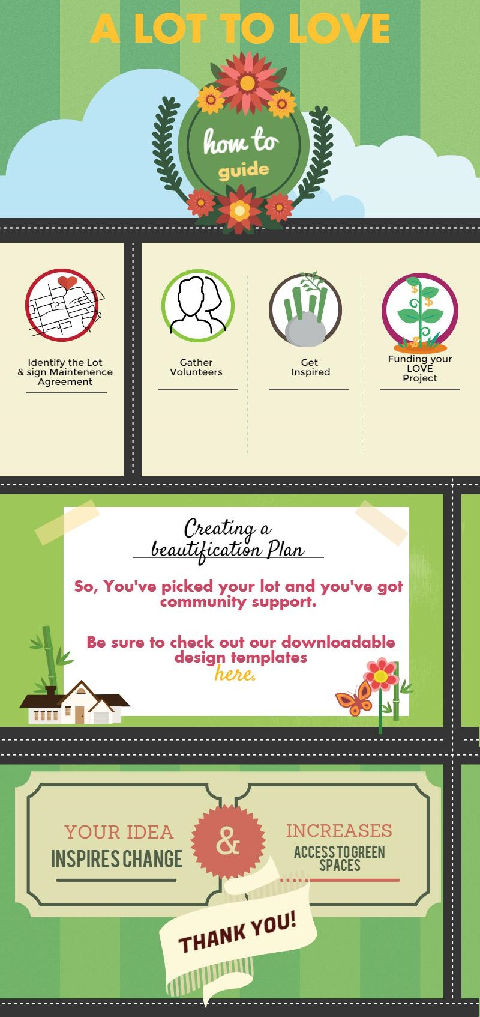I’M GOING TO MAKE AN INFOGRAPHIC

SIMILAR TO THIS. IT WILL BE A PDF, I AM STILL WORKING ON IT